Woodturning Tools

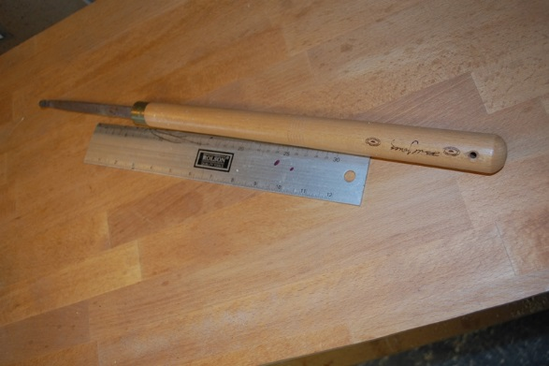

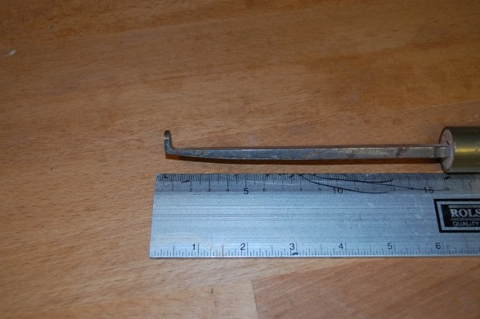

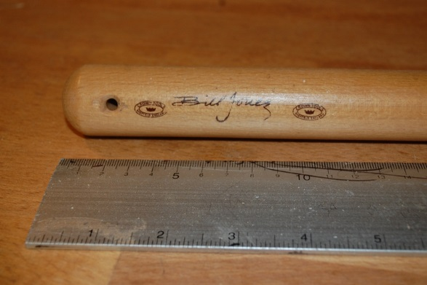

Bill Jones Thread Chasing Rest

£10 + Carriage

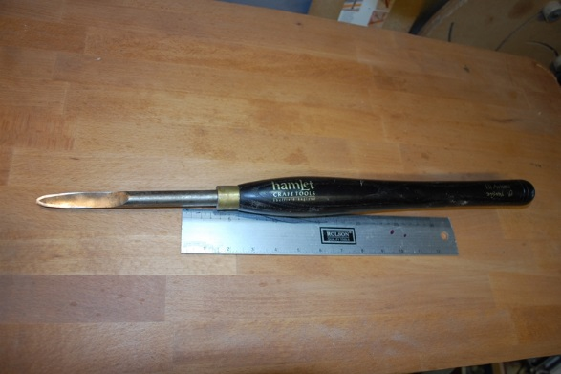

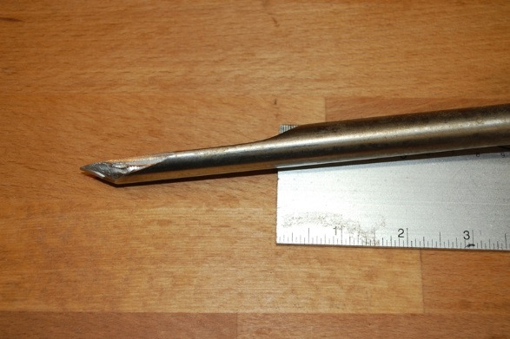

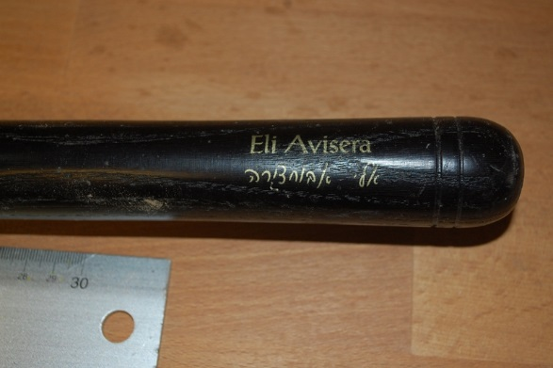

Hamlet Eli Avisera Half Round ¾” Combination Tool

(Now made by Ashly Isles)

£25 + Carriage

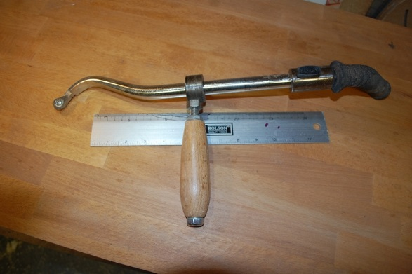

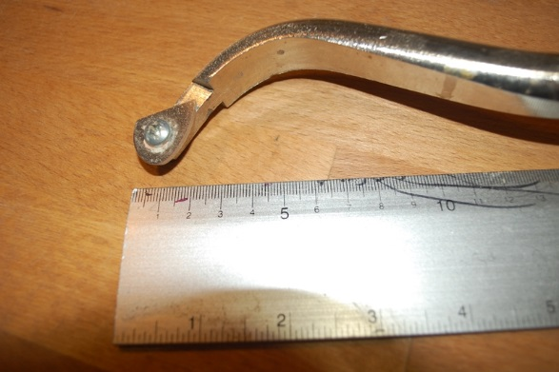

Sorby RS 210 Deep Hollowing System Scraper and side Handle with Teardrop Scraper

£45 + Carriage

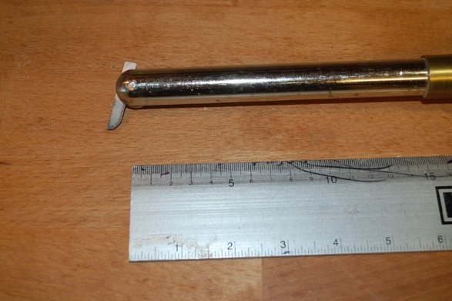
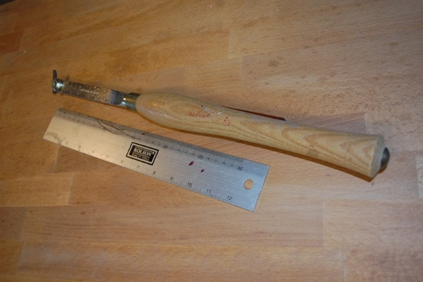
Sorby RS2000 KT Multi-Tip tool (but only this one tip available)

£45 + Carriage

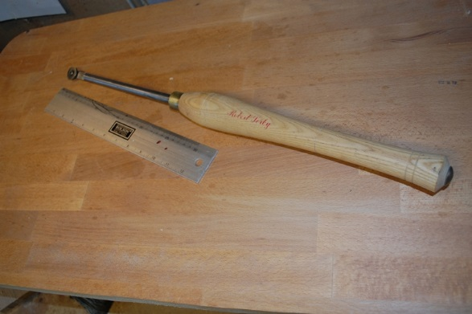
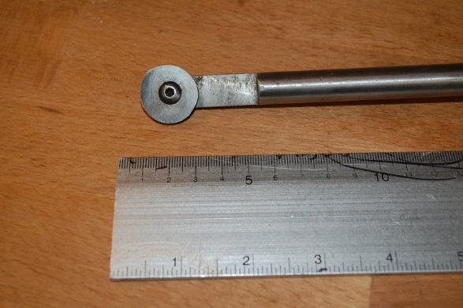
Sorby Scraping Tool (Round Bar)

£20 + Carriage

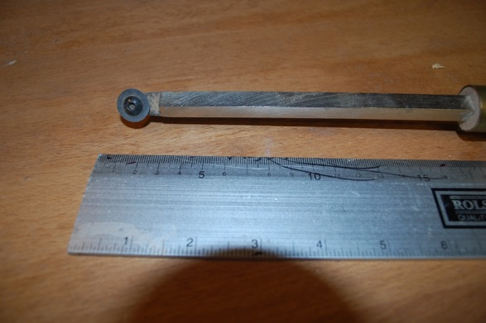
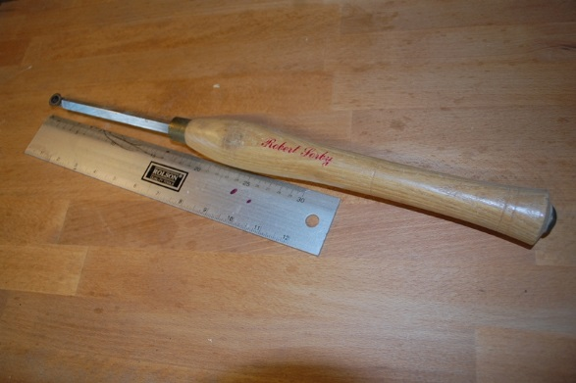

Sorby Scraping Tool (Square Bar)

£20 + Carriage

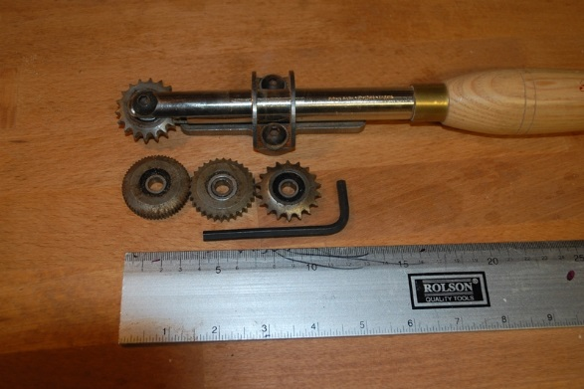
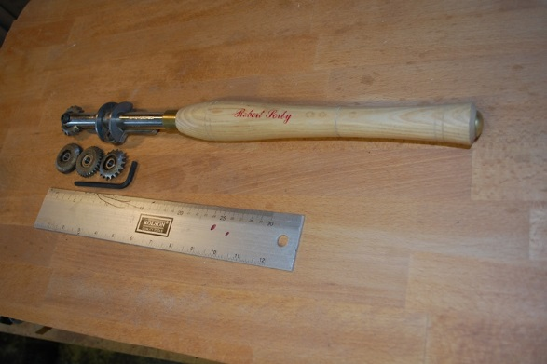
Sorby Spiraling & Texturing Tool with 4 cutters

£100 + Carriage

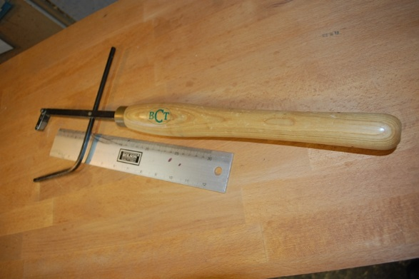

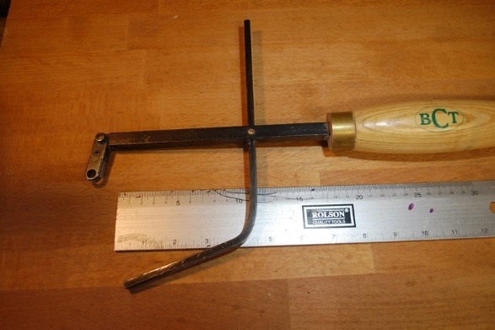

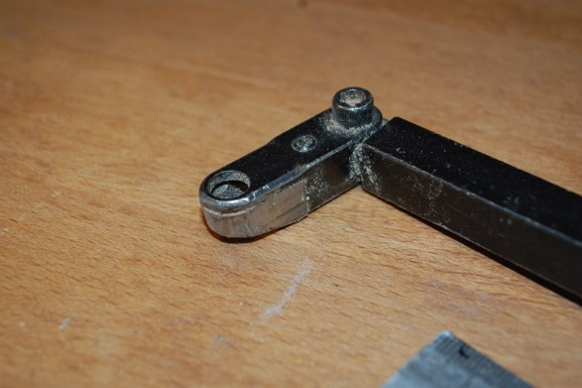

Toolpost BCT1001 HolloMate
Shielded ring type end-grain hollowing tool complete with cutter and stabiliser

£40 + Carriage

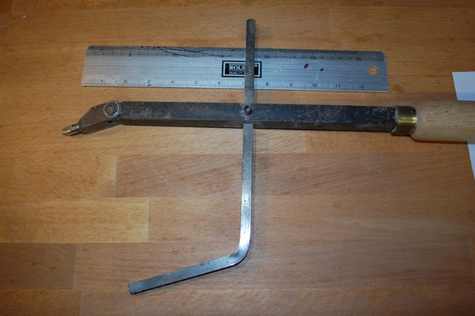
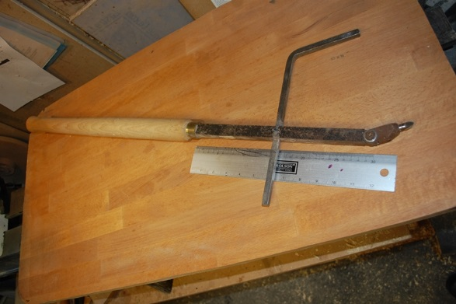

Toolpost BCT2001 Versatool II pick style hollowing tool complete with 8 mm cutting pick and stabiliser

£35 + Carriage

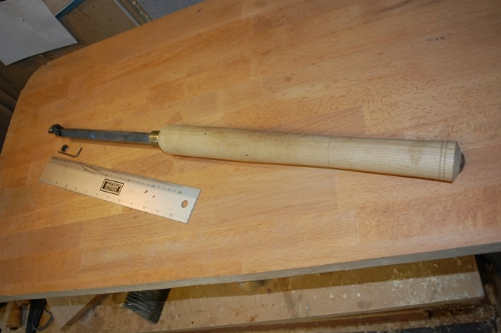

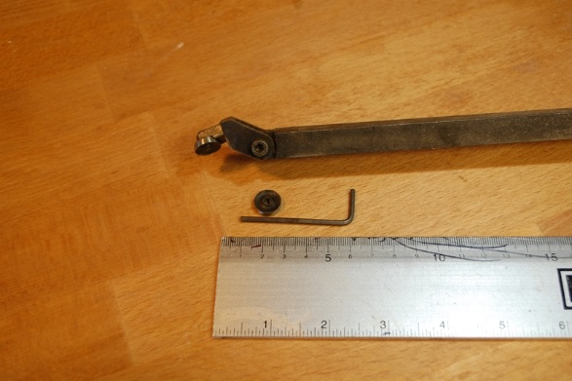

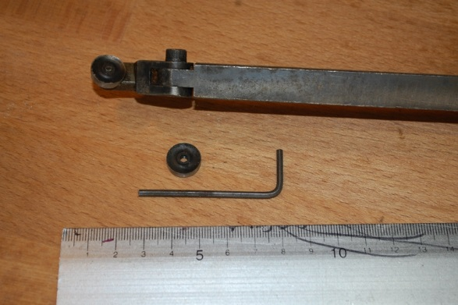

Toolpost BCT3020 Supercut II shear cutting bowl hollowing tool complete with 10mm cutter

£40 + Carriage

